Experiment 6.1
Determination and plotting of Parallel Plate Capacitance

Code File Name: Exp6_1_ParallelPlateCapacitance.m
Code
clc;
clear;
A=input("Enter the area value=");
d=input("Enter the thickness value=");
epsilon0=8.854*10^-12;
C=epsilon0*A/d;
disp('The capacitance is');
disp(C);
% Plot
x = linspace(0,10,50);
y = C * exp(-0.1 * x);
figure;
plot(x,y,'LineWidth',2);
xlabel('distance');
ylabel('capacitance');
title('Parallel plate capacitance');
Command Prompt
Enter the area value=8e-4
Enter the thickness value=3e-3
The capacitance is
2.3611e-12
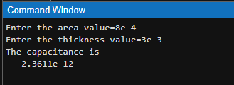

Output Graph
